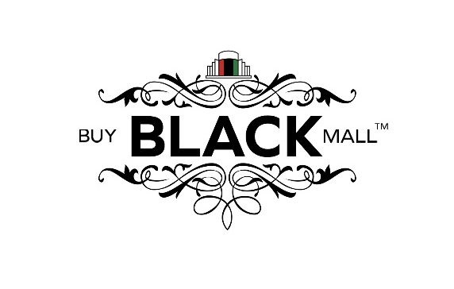
BBM Advertisement Form
Note: Please fill out and send via email to contact@bbmnc.com after you have read the terms and conditions and paid for your plan.
Owner’s Name:
Company Name:

Company Address:

Post address and map with advertisement? [ ] Yes [ ] No
Business Phone #:
Alternate # (OPTIONAL):
Email Address:
Web Address (OPTIONAL):
Company Bio:

Sales/Coupons/Specials (OPTIONAL):

Ads, Please send via email to contact@bbmnc.com
Photo (OPTIONAL), please send via email to contact@bbmnc.com:
Video (OPTIONAL), please send via email to contact@bbmnc.com
Additional info:

Your posting will appear within 24 hours of submission. Thank you!
Buy Black Mall, LLC

