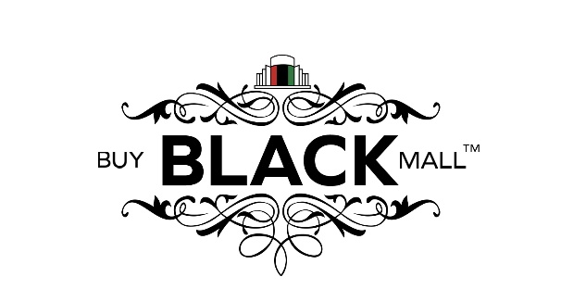
Buy Black Mall, LLC
Contractual Agreement
Terms and Conditions for Companies Without an Affiliate Program
By entering into this contract for subscription through PayPal, I agree to the terms and conditions set forth in this contract.
I understand that BBM is an online shopping mall and business directory service. I am confirming that I am a black-owned business or agent/salesperson within the United States and will pay a 6-month subscription fee of $120.00 or a one-time subscription payment of $240.00 per year via PayPal to be deducted through autopay from my debit/credit/bank account for these services.
The Legality of Business, Goods, and Services
I understand I am held liable for any false representation and/or issues related to my goods and services, including but not limited to, defective merchandise, undelivered goods or services, refunds, and exchanges of merchandise or services that I sell to a customer.
I understand that BBM is not a sales representative of my business nor will serve as a distributor of goods and services sold by my company.
I understand that I am responsible for all contractual legalities of my business such as, but not limited to:
▪ Federal/state filings, licenses, and registrations.
▪ Any federal/state goods or service-related filings, licenses, and registration.
▪ Any federal/state-related tax filings.
Online Service
I understand that for my fee of $120.00 or $240.00, I will receive the following accessibilities and services:
▪ To have my business included in the BBM’s business directory with free options, via electronic submission, of adding my owner and company name; company bio, address, phone #, and email address, photos and/or videos plus website link and map of the location.
▪ Weekly features posted on all BBM networks, social pages, and/or email marketing/advertising, and other advertising platforms.
Advertising
I understand that I am allowed to update my business information at any time by contacting BBM at contact@bbmnc.com.
I understand that BBM does not allow the following to be used or posted in an advertisement:
▪ Obscene, abusive or discriminatory language.
▪ Unlawful pornography, obscene gestures, or nudity (unless as an art-form medium for nudity only or legal adult pornography).
▪ Misrepresentation of goods and services.
▪ Illegal/unregistered businesses
Payment
I understand that for these services, the fee structure is as follows: ▪ $120.00/6 months or $240/year for each company listing.
▪ Payments will be processed through PayPal
▪ The monthly fee is good for one company advertisement and one related category listing.
▪ A $12.00 fee may be charged for insufficient funds upon the first autopay and $8.00 for the second attempt of autopay. These fees are imposed by the bank - not BBM. I am aware I may also incur additional fees from my own bank. If no monthly fee can be collected, my advertisement will be canceled.
▪ I understand that once my fee has been paid through PayPal, the transaction will be considered as an offer and acceptance of this contract. I will then receive an email response allowing me to send my advertising information to be posted.
Contract Renewal
I understand this contract will automatically renew itself after and can be canceled according to the terms under “Termination of Contract” as listed below.
Cancellation
I understand that I have the right to cancel this contract for any reason which will terminate on the last date of the month requested. No refunds will be awarded.
Termination of Contract
I understand that BBM retains the right to terminate this contract should any guidelines under this contract be violated without a refund.
I understand that a notice of termination must be given NO LATER THAN 7 DAYS through the cancellation of my PayPal autopay prior to the forthcoming month of the requested month to start termination otherwise, I will be charged an additional month’s fee.
I understand that by making my first payment through PayPal, an offer and acceptance have been made according to this contract.
Buy Black Mall, LLC
WWW.BBMNC.COM

